UDC

Article Title

First Author1, Second Author2*, Third Author1,2

*1Laboratory X, Institute X, Department X, Organization X, City X, Country*

*2Laboratory X, Institute X, Department X, Organization X, City X, Country*

**\***Corresponding Author, email@ gmail.com.

Abstract

As a primary goal, the abstract should make the general significance and conceptual advance of the work clearly accessible to a broad readership. A concise and factual abstract is required (150-250 words). The abstract should state briefly the purpose of the research, the principal results and major conclusions.

Keywords: keyword1, keyword2, keyword3, keyword4, keyword5. (Min. 5 – Max. 8).

# 1. Introduction

# Succinct, without subheadings. State the objectives of the work and provide an adequate background, avoiding a detailed literature survey or a summary of the results. References in the text should be given by placing in bracket [1], [1, 2, 3].

2. **Material and methods**

Provide sufficient details to allow the work to be reproduced by an independent researcher. Methods that are already published should be summarized, and indicated by a reference. Any modifications to existing methods should also be described. For experiments reporting results on animal or human subject research, an ethics approval statement should be included in this section.

*2.1. Sample collection and preparation*

*2.2. Biochemical analysis and statistics*

3. **Results**

Results should be clear and concise. This section may be divided by subheadings. Results section should contain a description of the experimental data, with a focus on consistent patterns in observations; include tables and figures, not duplicative.

All illustrations, figures, and tables are placed within the text at the appropriate points, rather than at the end. The text of the manuscript should contain links to figures. Each table should have a number and title, while each figures – a number and legend.

An example of the design of tables and figures.

Table 1 – Table title.

|  |  |  |  |  |  |
| --- | --- | --- | --- | --- | --- |
| **Animal species** | **No. examined** | **No. (%) infected** | **CI (95%)** | **SD** | **Identifiedspecies** |
| lynx *(Lynx lynx)* | 3 | 2 (66.6) | 2.33±2.32  (0.01 to 4.65) | 2.05 | *Toxocara cati* |
| Total: | 3 | 2 (66.6) | 2.33±2.32  (0.01 to 4.65) | 2.05 |  |

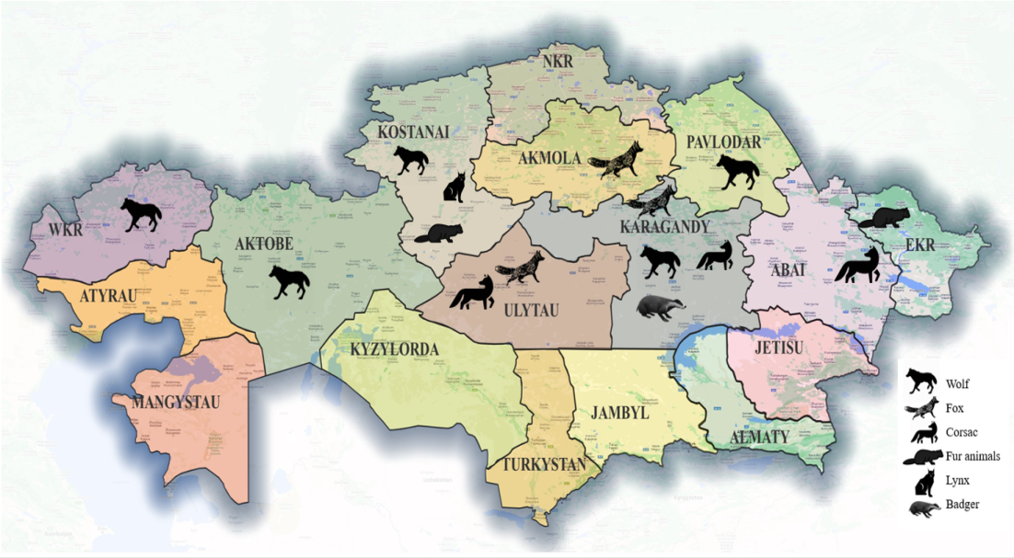

Figure 1 – Figure name.

4. **Discussion**

This should explore the significance of the results of the work, not repeat them. Discussions should cover the key findings of the study, discuss any prior research related to the subject, discuss the potential shortcomings and limitations on their interpretations, discuss their integration into the current understanding of the problem, and freely postulate theories that could be tested in the future.

**Acknowledgments**

This is a short text to acknowledge the contributions of specific colleagues or institutions that aided the efforts of the authors.

**Funding sources**

List funding sources in this standard way: This work was supported by the Ministry of Science and Higher Education of the Republic of Kazakhstan to frame project [grant numbers xxxx, yyyy].

# Conflict of Interest

# This note should be added in a separate section before the reference list after the acknowledgment. If there exist no conflict, the authors should state no conflict of interest.

# Reference styles

List of references should be presented in two sections, namely, LITERATURE and REFERENCES. References should be cited in accordance with GOST 7.1-2003 (requirement for publications included in the COKNVO list). The order of references in the list must match the order of their citation in the text, figures and tables. References to unpublished data are not allowed. References should be in square brackets. Number of sources in the original paper should not exceed 25, in a review manuscript no more than 50 sources.

1. Tamura K., Stecher G., Kumar S. MEGA11: Molecular Evolutionary Genetics Analysis Version 11 // Molecular Biology and Evolution. – 2021. – Vol. 38(7). – P. 3022-3027. <https://doi.org/10.1093/molbev/msab120>.

2. Uakhit R., Smagulova A., Lider L., Leontev S., Berber A., Kiyan V. Species composition of wolf (*Canis Lupus*) helminth fauna in Kazakhstan // Eurasian Journal of Applied Biotechnology. – 2022. – Vol. 1. – P. 49–58. <https://doi.org/10.11134/btp.1.2022.6>.

3. Шабдарбаева Г. С., Ялышева С. В. Ретроспективный анализ распространенности эхинококкоза на территории Республики Казахстан // Вестник Национальной академии наук Республики Казахстан. – 2020. - № 6. – С. 68-70.

The second section REFERENCES must fully replicate the list of references in the original language. English sources are duplicated in the list of REFERENCES. Kazakh-language (and other) links should be brought to the Roman alphabet (Latin), and English translation. Reference must additionally contain DOI (Digital Object Identifier) or PMID (PubMed identifier or PubMed unique identifier) ​​​​if available.

1. Tamura K., Stecher G., Kumar S. (2021) MEGA11: Molecular Evolutionary Genetics Analysis Version 11. Molecular Biology and Evolution., vol. 38(7), pp. 3022-3027. <https://doi.org/10.1093/molbev/msab120>.

2. Uakhit R., Smagulova A., Lider L., Leontev S., Berber A., Kiyan V. (2022) Species composition of wolf (Canis Lupus) helminth fauna in Kazakhstan. Eurasian Journal of Applied Biotechnology., vol. 1, pp. 49–58. <https://doi.org/10.11134/btp.1.2022.6>.

3. Shabdarbaeva G. S., Jalysheva S. V. (2020) Retrospektivnyj analiz rasprostranennosti jehinokokkoza na territorii Respubliki Kazahstan [Retrospective analysis of the prevalence of echinococcosis in the territory of the Republic of Kazakhstan]. Vestnik Nacional'noj akademii nauk Respubliki Kazahstan, vol. 6, pp. 68-70.

50% references must be of research/review papers published during past five years. Review article: 60% references must from papers published during past five years. References in the text should be given by placing in bracket [1], [1, 2, 3]. Reference list must be prepared accordingly.

УДК

**Название статьи**

Первый автор1, Второй автор2*, Третий автор1,2

*1Лаборатория X, Институт X, Отделение X, Организация X, Город X, Страна*

*2Лаборатория X, Институт X, Отдел X, Организация X, Город X, Страна*

*Автор-корреспондент, email@gmail.com.

* **Абстракт**
* Основная цель аннотации является донести общую значимость и концептуальное развитие работы ясным и доступным широкой читательской аудитории языком. Требуется краткое и четкое резюме (150-250 слов). В аннотации должны быть кратко изложены цель исследования, основные результаты и основные выводы.

**Ключевые слова:** ключевое слово1, ключевое слово2, ключевое слово3, ключевое слово4, ключевое слово5. (Мин. 5 – Макс. 8).

ӘОЖ

**Мақаланың тақырыбы**

Бірінші автор1, Екінші автор2*, Үшінші автор1,2

*1Зертхана X, Институт X, Бөлім X, Ұйым X, Қала X, Ел*

*2Зертхана X, Институт X, Бөлім X, Ұйым X, Қала X, Ел*

*Корреспондент автор, email@gmail.com.

* **Абстракт**

Аннотацияның негізгі мақсаты – шығарманың жалпы мәні мен тұжырымдамалық дамуын түсінікті және қалың оқырманға қолжетімді тілде жеткізу. Қысқа және нақты түйіндеме (150-250 сөз) қажет. Аннотацияда зерттеу мақсаты, негізгі нәтижелер мен негізгі қорытындылар қысқаша көрсетілуі керек.

**Түйін сөздер**: кілт сөз1, кілт сөз2, кілт сөз3, кілт сөз4, кілт сөз5. (Кем. 5 – Макс. 8).